22.61: a) For a sphere NOT at the coordinate origin:
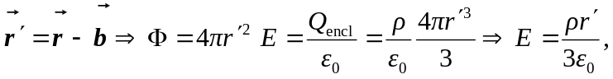
in the 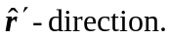
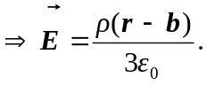
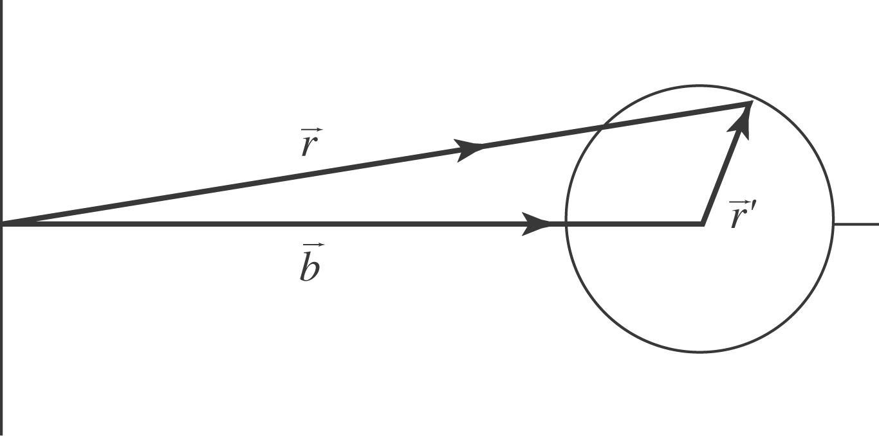

b) The electric field inside a hole in a charged insulating sphere is:
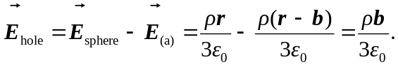
Note that 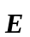 is uniform.

